|  |  |
| --- | --- |
| Ex.No:2 | Finding Square Root of a given number using Newton’s Method |
|  |

***Aim:***

To develop a python program to find the square root of given number using Newton’s Iterative method.

***Algorithm:***

|  |  |
| --- | --- |
| **Step 1:** | Start Process |
| **Step 2:** | Get a number from user |
| **Step 3:** | Assume root as 1 and assign to guess |
| **Step 4:** | Compute f(x) by guess * guess and subtract the number |
| **Step 5:** | Compute d(x) by 2 * guess |
| **Step 6:** | Compute actual root as guess subtract with f(x) divided by d(x) and store the value in actual |
| **Step 7:** | Compare guess with actual |
| **Step 8:** | If guess and actual are equal print the root value of a number is actual value and goto Step 10 |
| **Step 9:** | Else assign guess with actual and goto Step 4 |
| **Step 10:** | Stop Process |

***Flow Chart:***

***Pseudo Code:***

START

READ number

SET guess = 1

WHILE TRUE

COMPUTE fx=guess * guess – number

COMPUTE dx=2 * guess

COMPUTE actual = guess – (fx/dx)

IF actual is equal to guess THEN

PRINT “Square root value of given number ” number “ is ” actual

ELSE

ASSIGN guess as actual

END IF

END WHILE

STOP

***Program:***

*newtonmethod.py*

print("Enter the number to find the root");

number=int(input())

guess = 1

while True:

fx = guess*guess - number

dx = 2*guess

actual = guess - ((fx)/dx)

actual = round(actual,4)

if guess == actual:

print("Root of given number ",number," is ",actual)

break

else:

guess = actual

***Output***

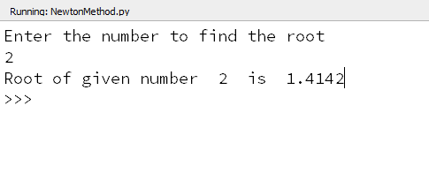

***Result:***

Thus the program to find the square root of the given number using Newton’s iterative method was developed and tested successfully.